Donald and Jean

The Sierra Nevada Unit, WBCCI has had a very successful year in 2014. We still have some great rallies and lunches ahead. This was due in large part to the support and involvement of our membership in everything from attendance at rallies to governance of the Unit.
We hope that you will continue to support the SNU by renewing your membership for 2015 and by participating in SNU. You have several options to renew your membership. You can go to our website, fill in the form, and pay online. You can print out the web form, or you can use the enclosed form and mail it with a check for dues to:
SNU Treasurer
716 Terra Ct, Reno, NV 89506
http://sierranevadaairstreams.org/snu/dues/15dues/app-form.html
Its what you don't see that makes the SNU great! There are lot of things that need to get done so we can get together with our Airstreams, enjoy our friends and meet new friends. Belonging means helping out in keeping the SNU strong. What can you do?
- Govern – serve on the board and help decide what needs to be done between member meetings
- Record – take notes at the meeting so the Unit has a good record of decisions made (Unit Secretary)
- Telephone – call members we haven't seen in a while to find out how they are doing and encourage participation in Unit events
- Host – help take care of event scheduling and provide information about various rally and luncheon sites.
- Write – provide articles for the SNU newsletter and other publications.
By utilizing all the collective talents and skills of it's members the SNU can continue to grow and develop. Getting involved is a great way to show your support of the SNU. The health and vitality of the SNU is dependent on the participation of its membership. Please feel free to provide any feedback, ideas, or suggestions that you feel would assist the SNU to be the kind of Airstream group that you want to be an active and enthusiastic member of.
We thank you for your past support and look forward to receiving your dues renewal for 2015. We also look forward to your participation in rallies and other activities of the SNU in the coming year.

Sincerely
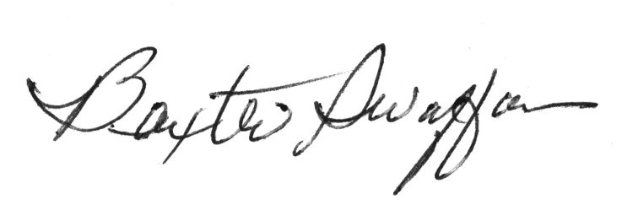
Baxter Swaffer, Treasurer/Membership SNU

